

oneM2M
Technical Report
Document Number | oneM2M-TR-0043-V-0.1.0
Document Name: | Modbus Interworking
Date: | 2017-04-07
Abstract: | This technical report investigates oneM2M and modbus interworking scenarios and proposes possible solutions to support the interworking scenarios.
Template Version: January 2017 (Do not modify)

The present document is provided for future development work within oneM2M only. The Partners accept no liability for any use of this report.
The present document has not been subject to any approval process by the oneM2M Partners Type 1. Published oneM2M specifications and reports for implementation should be obtained via the oneM2M Partners' Publications Offices.

About oneM2M
The purpose and goal of oneM2M is to develop technical specifications which address the need for a common M2M Service Layer that can be readily embedded within various hardware and software, and relied upon to connect the myriad of devices in the field with M2M application servers worldwide.
More information about oneM2M may be found at: http//www.oneM2M.org
Copyright Notification
© 2017, oneM2M Partners Type 1 (ARIB, ATIS, CCSA, ETSI, TIA, TSDSI, TTA, TTC).
All rights reserved.
The copyright and the foregoing restriction extend to reproduction in all media.

Notice of Disclaimer & Limitation of Liability
The information provided in this document is directed solely to professionals who have the appropriate degree of experience to understand and interpret its contents in accordance with generally accepted engineering or other professional standards and applicable regulations. No recommendation as to products or vendors is made or should be implied.
NO REPRESENTATION OR WARRANTY IS MADE THAT THE INFORMATION IS TECHNICALLY ACCURATE OR SUFFICIENT OR CONFORMS TO ANY STATUTE, GOVERNMENTAL RULE OR REGULATION, AND FURTHER, NO REPRESENTATION OR WARRANTY IS MADE OF MERCHANTABILITY OR FITNESS FOR ANY PARTICULAR PURPOSE OR AGAINST INFRINGEMENT OF INTELLECTUAL PROPERTY RIGHTS. NO oneM2M PARTNER TYPE 1 SHALL BE LIABLE, BEYOND THE AMOUNT OF ANY SUM RECEIVED IN PAYMENT BY THAT PARTNER FOR THIS DOCUMENT, WITH RESPECT TO ANY CLAIM, AND IN NO EVENT SHALL oneM2M BE LIABLE FOR LOST PROFITS OR OTHER INCIDENTAL OR CONSEQUENTIAL DAMAGES. oneM2M EXPRESSLY ADVISES ANY AND ALL USE OF OR RELIANCE UPON THIS INFORMATION PROVIDED IN THIS DOCUMENT IS AT THE RISK OF THE USER.

Contents
Contents 3
1 Scope 4
2 References 4
2.1 Normative references 4
2.2 Informative references 4
3 Definitions, symbols and abbreviations 5
3.1 Definitions 5
3.2 Symbols 5
3.3 Abbreviations 5
4 Conventions 6
5 Introduction 6
5.1 Background 6
5.2 Architecture and protocol stack 6
5.3 Key feature 8
5.4 Data model 9
6 Scenarios for oneM2M and Modbus Interworking 9
7 Possible Solutions for oneM2M and Modbus Interworking 10
Proforma copyright release text block 10
Annexes 10
Annex <y>: Bibliography 11
History 11

1 Scope
The present document studies to enhance oneM2M system to support interworking with modbus devices for horizonally extending oneM2M platform. The objectives of the Technical Report are to investigate interworking between modbus device and the oneM2M system:
- Enhancements for oneM2M system support interworking with Modbus device, such as supporting Master-slaver communication method
- Modbus data model is mapped to oneM2M resources
- Instantiating Modbus data model by usage of oneM2M base ontology
- Interworking procedure by operating oneM2M resource and reusing Gerneric Interworking
Furthermore, depending on the study result of the TR, normative works may be followed as CRs to the existing TSes.

2 References
The following text block applies.
References are either specific (identified by date of publication and/or edition number or version number) or non-specific. For specific references,only the cited version applies. For non-specific references, the latest version of the referenced document (including any amendments) applies.
NOTE: While any hyperlinks included in this clause were valid at the time of publication oneM2M cannot guarantee their long term validity.

2.1 Normative references
As a Technical Report (TR) is entirely informative it shall not list normative references.
The following referenced documents are necessary for the application of the present document.
Not applicable.

2.2 Informative references
Clause 2.2 shall only contain informative references which are cited in the document itself.
The following referenced documents are not necessary for the application of the present document but they assist the user with regard to a particular subject area.
[i.1] oneM2M Drafting Rules (http://member.onem2m.org/Static_pages/Others/Rules_Pages/oneM2M-Drafting-Rules-V1_0.doc)
[i.2] Modbus website, http://www.modbus.org/
[i.3] Modbus_Application_Protocol_V1_1b3, Modbus Organization
[i.4] Modbus_Messaging_Implementation_Guide_V1_0b, Modbus Organization
[i.5] Modbus_over_serial_line_V1_02, Modbus Organization
[i.6] oneM2M TR-0009: "Protocol_Analysis".

3 Definitions, symbols and abbreviations
Delete from the above heading the word(s) which is/are not applicable.

3.1 Definitions
Clause numbering depends on applicability.
- A definition shall not take the form of, or contain, a requirement.
- The form of a definition shall be such that it can replace the term in context. Additional information shall be given only in the form of examples or notes (see below).
- The terms and definitions shall be presented in alphabetical order.
For the purposes of the present document, the [following] terms and definitions [given in ... and the following] apply:
Definition format
<defined term>: <definition>
If a definition is taken from an external source, use the format below where [N] identifies the external document which must be listed in Section 2 References.
<defined term>[N]: <definition>
example 1: text used to clarify abstract rules by applying them literally
NOTE: This may contain additional information.

3.2 Symbols
Clause numbering depends on applicability.
For the purposes of the present document, the [following] symbols [given in ... and the following] apply:
Symbol format
<symbol> <Explanation>
<2nd symbol> <2nd Explanation>
<3rd symbol> <3rd Explanation>

3.3 Abbreviations
Abbreviations should be ordered alphabetically.
Clause numbering depends on applicability.
For the purposes of the present document, the [following] abbreviations [given in ... and the following] apply:
Abbreviation format
<ABBREVIATION1> <Explanation>
<ABBREVIATION2> <Explanation>
<ABBREVIATION3> <Explanation>

4 Conventions
The key words “Shall”, ”Shall not”, “May”, ”Need not”, “Should”, ”Should not” in this document are to be interpreted as described in the oneM2M Drafting Rules [i.1]

5 Introduction

5.1 Background
This clause introduces the background of Modbus,including origin of Modbus, status quo and so on.
Modbus was first introduced by Modicon® (now part of Schneider Electric®) for process control systems. It is used to establish master-slave/client-server communication between intelligent devices and sensors and instruments. It is a de facto standard, truly open and the most widely used network protocol in the industrial manufacturing environment.
Modbus is easy to deploy and maintain, and used across a wide range of industries. It is also an ideal protocol for remote terminal unit (RTU) applications where wireless communication is required. Modbus is not only an industrial protocol. Building, infrastructure, transportation and energy applications also make use of its benefits.
Originally, Modbus was implemented as an application level protocol intended to transfer data over serial port, it has expanded to include implementations over serial, TCP/IP, and UDP. Today, it is a common protocol used by countless devices for simple, reliable, and efficient communication across a variety of networks. Modbus was designed as a request-response protocol with a flexible data and function model that are part of the reason it is still in use today. In addition, support for the simple and elegant structure of Modbus continues to grow.

5.2 Architecture and protocol stack
This clause introduces generic Modbus network architecture and protocol description as basic information for interworking.
The Modbus protocol follows a master and slave architecture where a master transmits a request to a slave and waits for the response (as shown in figure5.2-1). This architecture gives the master full control over the flow of information, which has benefits on older multidrop serial networks. Even on modern TCP/IP networks, it gives the master a high degree of control over slave behavior, which is helpful in some designs.
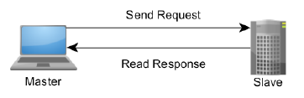
Figure 5.2-1 The Master-Slave, Request-Response Relationship of Modbus device
The Modbus protocol allows an easy communication within all types of network (as shown in Figure 5.2-2). Every type of devices (such as PLC, Driver, Motion control, I/O Device…) can use Modbus protocol to initiate a remote operation.
The same communication can be done as well on serial line as on an Ethernet TCP/IP networks. Gateways allow a communication between several types of buses or network using the Modbus protocol.
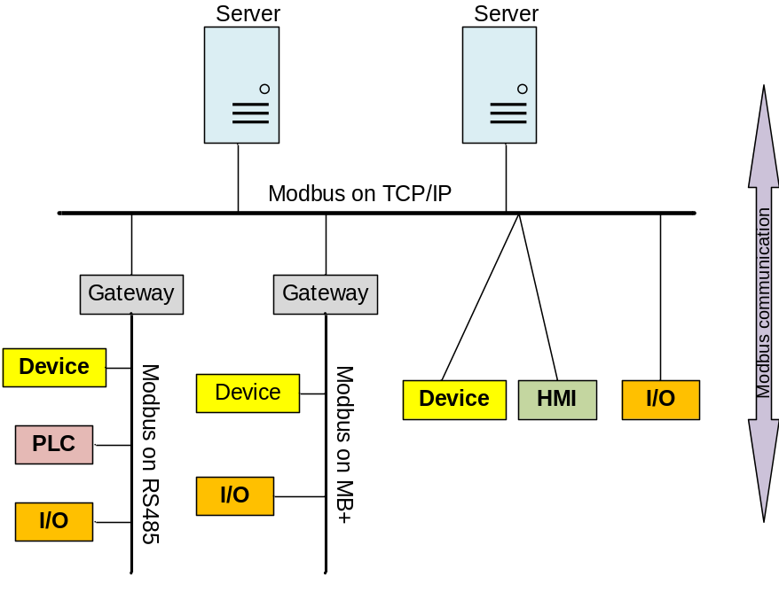
Figure 5.2-2 Modbus Network Architecture

There are many variants of Modbus protocols:
- Modbus RTU — This is used in serial communication & makes use of a compact, binary representation of the data for protocol communication. Modbus RTU is the most common implementation available for Modbus. A Modbus RTU message must be transmitted continuously without inter-character hesitations.
- Modbus ASCII — This is used in serial communication and makes use of ASCII characters for protocol communication.
- Modbus TCP/IP or Modbus TCP — This is a Modbus variant used for communications over TCP/IP networks. It does not require a checksum calculation as lower layers already provide checksum protection.
- Modbus over TCP/IP or Modbus over TCP or Modbus RTU/IP — This is a Modbus variant that differs fromModbus TCP in that a checksum is included in the payload as with Modbus RTU.
- Modbus over UDP — Some have experimented with using Modbus over UDP on IP networks, which removes the overheads required for TCP.
- Modbus Plus (Modbus+, MB+ or MBP) — Modbus Plus is proprietary to Schneider Electric® and unlike the other variants, it supports peer-to-peer communications between multiple masters. It requires a dedicated co-processor to handle fast HDLC-like token rotation. It uses twisted pair at 1 Mbit/s and includes transformer isolation at each node, which makes it transition/edge triggered instead of voltage/level triggered.
At present, Modbus TCP is more efficient networking through the use of dedicated connections and identifiers for each request and response. Modbus RTU and Modbus ASCII are older serial ADU formats with the primary difference between the two being that RTU uses a compact binary representation while ASCII sends all requests as streams of ASCII characters.
The Modbus protocol defines a simple protocol data unit (PDU) independent of the underlying communication layers. The mapping of Modbus protocol on specific buses or network can introduce some additional fields on the application data unit (ADU). The Modbus frame is as shown in figure 5.2-3.

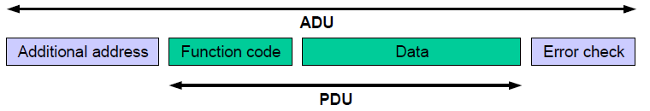
Figure 5.2-3 Modbus Frame
A Modbus frame or Modbus Application Data Unit (ADU) consists of the following:
- Additional address field: A field containing additional addresses used by the underlying communication protocol. It is 1 byte slave address over serial links (such as RS 232, RS 485). For Modbus TCP, it is called Modbus Application Protocol (MBAP) Header that include transaction identifier, protocol identifier, length and unit identifier.
- Modbus PDU: It is independent of underlying communication layer and consists of two parts: 1) 1-byte Function code to indicate identity of the requested service, 2) Variable length data field containing payload of the requested service. There are three types of Modbus PDUs: Modbus Request, Modbus Response and Modbus Exception.
- An optional error check field. Modbus TCP is not needed.

5.3 Key feature
This clause introduces the key features of Modbus, such as communication model,characteristics of data model, simple format and so on.
There are many devices and gateways that support Modbus, as it is a very simple protocol and convenient to transmit and understand. Specially, Modbus TCP/IP simply takes the Modbus instruction set and wraps TCP/IP around it. If you already have a Modbus driver and you understand Ethernet and TCP/IP sockets, you can have a driver up and running and talking to a PC in a few hours. Development costs are exceptionally low. Minimum hardware is required, and development is easy under any operating system. The following are key features of Modbus:
- Communication mode
Modbus uses master-slave/client-server communication mode, Master issues a unicast request and slave responds to that. In serial and MB+ networks, only the node assigned as the Master may initiate a command. On Ethernet, any device can send out a Modbus command, although usually only one master device does so. Modbus also supports broadcast mode where master’s request is sent to all the slaves but no slave responds to broadcast request.
- Data model
Modbus manages the access of data simply and flexibly. Modbus data are divided into four ranges, they are that these types of data can be provided/alterable by I/O system or an application program. In most cases, slaves store each type of data that it supports in separate memory, and limits the number of data elements that a master can access.
- Function code
There are three categories of Modbus Function codes, including Public Function codes, User-Defined Function codes and Reserved Function codes. Public Function codes can satisfy common operations, such as accessing data in device by reading and writing data model, and simply diagnosing device. Function code is flexibility that user can select and implement a function code by self-defining User-Defined Function codes according to service requirements.
- Availability of many devices
Interoperability among different vendors' devices and compatibility with a large installed base of Modbus-compatible devices makes Modbus an excellent choice.

5.4 Data model
The Modbus standard defines bit-addressable and 16-bit word addressable input and output data items. Modbus bases its data model on a series of tables that have distinguishing characteristics. The four primary tables for data model are as following:
Table 5.4-1 Modbus data model table
Primary tables | Object type | Type of access | Comments
Discretes Input | Single bit | Read-Only | This type of data can be provided by an I/O system, e.g. read the status of switch
Coils | Single bit | Read-Write | This type of data can be alterable by an application program, e.g. switch on a transducer
Input Registers | 16-bit word | Read-Only | This type of data can be provided by an I/O system, e.g. read temperature on a sensor
Holding Registers | 16-bit word | Read-Write | This type of data can be alterable by an application, e.g. set value to a controller.

There are two ways of organizing the data in device. Each device can have its own organization of the data according to its application. The figure 5.4-1 below shows an example for data organization in a device having digital and analog, inputs and outputs. Data block (device application memory) is accessible with different Modbus functions, such as read coils, write holding registers. All the data elements handled via Modbus can be located in device application memory by reference numbers form 1to n. The pre-mapping between the Modbus data model and the device application is totally vendor device specific.
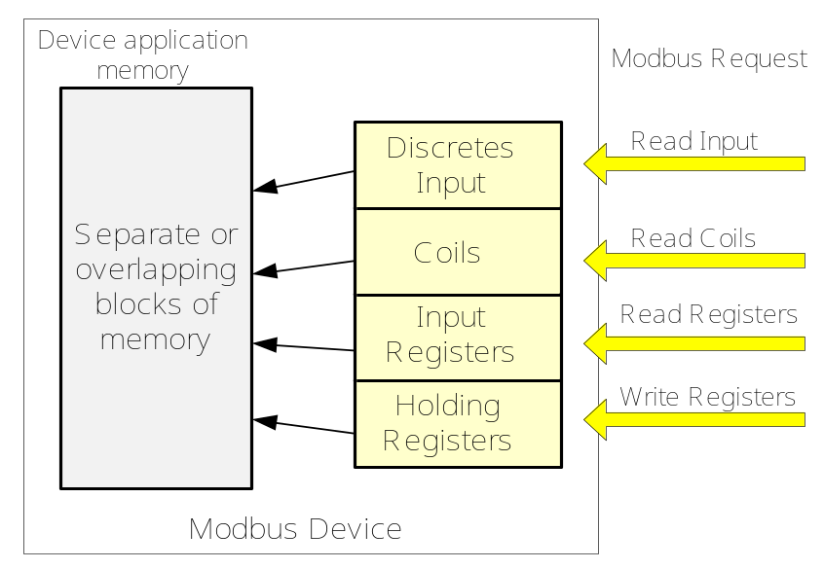
Figure 5.4-1 Implementation example of Modbus data model

6 Scenarios for oneM2M and Modbus Interworking
This clause studies the scenarios for oneM2M and Modbus Interworking, such as Modbus-based device can connect to IN directly or via MN/ASN, and Modbus-based devices can connect to each other via IN/MN/ASN.

7 Possible Solutions for oneM2M and Modbus Interworking
This clause studies the possible solutions to realize oneM2M interworking with Modbus. Modbus-based devices can interwork with oneM2M system by usage of IPE that deploys on ASN, MN and IN, such as Modbus-based device connects to MN by IPE on MN. Resource mapping based on Modbus data model and operational procedure will be studied. Semantic method will also be consided in the solution.

Proforma copyright release text block
This text box shall immediately follow after the heading of an element (i.e. clause or annex) containing a proforma or template which is intended to be copied by the user. Such an element shall always start on a new page.
Notwithstanding the provisions of the copyright clause related to the text of the present document, oneM2M grants that users of the present document may freely reproduce the <proformatype> proforma in this {clause|annex} so that it can be used for its intended purposes and may further publish the completed <proformatype>.
<PAGE BREAK>

Annexes
Each annex shall start on a new page (insert a page break between annexes A and B, annexes B and C, etc.).
Use the Heading 9 style for the title and the Normal style for the text.
Annex <A>:
Title of annex (style H9)
<Text>
<PAGE BREAK>
Annex <B>:
Title of annex (style H9)
<Text>
B.1 First clause of the annex (style H1)
<Text>
B.1.1 First subdivided clause of the annex (style H2)
<Text>
<PAGE BREAK>

Annex <y>:
Bibliography
The annex entitled "Bibliography" is optional.
It shall contain a list of standards, books, articles, or other sources on a particular subject which are not mentioned in the document itself.
It shall not include references mentioned in the document.
Use the Heading 9 style for the title and B1+ or Normal for the text.
- <Publication>: "<Title>".
OR
<Publication>: "<Title>".
<PAGE BREAK>

History
This clause shall be the last one in the document and list the main phases (all additional information will be removed at the publication stage).
Publication history
V1.1.1 | <yyyy-mm-dd> | <Milestone>

Draft history (to be removed on publication)
V0.0.1 | 2017-03-27 | Initial Skeleton
V0.1.0 | 2017-04-07 | Incorporated contributions:  ARC-2017-0131R02-Modbus_Introduction

